

OPTIONS SYMBOLOGY INITIATIVE

INTRODUCTION 2

CURRENT DTN OPTIONS SYMBOLOGY 2

NEW DTN OPTIONS SYMBOLOGY 2

MONTH CODE/PUT/CALL AND NON STANDARD OPTIONS 3

SAMPLES OF CURRENT DTN SYMBOLOGY CODES 4

DISPLAY CHANGES FOR DTNIQ 6

OCC SCHEDULES AND CUT-OVER TO NEW DTN OPTIONS SYMBOLOGY 7

MILESTONE DATES FOR OPTION SYMBOLOGY CONVERSION 8

COMMUNICATION 9

Document Version 4f
Date of issue: October 16, 2009

INTRODUCTION
The Options Symbology Initiative (OSI) is an industry plan to change the symbology used in representing options listed contracts. The OSI is being coordinated by Options Clearing Corporation (OCC). As a result of this initiative, DTN will be changing its Options symbology for all DTN platforms and begin disseminating the new equity and index symbol format in accordance with the OCC and Options Symbology Initiative.
CURRENT DTN OPTIONS SYMBOLOGY
The current Options Symbology consists of a Symbol Root, 1 letter Month Code and 1 letter Strike Code

Example:
A Motorola October 2009 7.00 CALL is represented as:
MOT JJ
Where:
Root Symbol = MOT
Month Code = J (October Call)
Price Code = J (7.00 Strike Price Code)

NEW DTN OPTIONS SYMBOLOGY
DTN is using the OPRA feed, and due to the OSI initiative, OPRA will make modifications to their feed and discontinue population of the strike price code. OPRA will modify their feed and data elements. DTN will change and expand the current options symbology format for all products. The new Options Symbology key will consist of the following data elements:

Security Symbol
The security symbol will have a maximum of 5 characters and may contain digits.
In those instances where there is a 5 character underlying with a corporate action, the symbol will be converted into a 5 character symbol.

Expiration Year
The expiration year will have a maximum of 2 digits (example: year 2009 = 09)

Expiration Date
The expiration date will have a maximum of 2 digits.

Expiration Month
The expiration month is a single character code and represents month/put/call.
Example: Month code for July Call = G and July Put = S

Strike Price
The strike price will have a maximum of 7 characters with leading/trailing 0s trimmed and decimal point included if necessary
CURRENT SYMBOL NEW DTN SYMBOL
MOT JJ (Motorola October Call at 7.00 Expiring on 10/17/09) MOT0917J7
FDX SX (Fed Ex August Put at 22.50 Expiring on 07/18/09) FDX0918S22.5
CYQ ME (Cisco January Put at 25.00 Expiring on 01/16/10) CSCO1016M25
QZN DB(Amazon April Call at 110.00 Expiring on 04/17/10 AMZN1017D110

PRE-CONSOLIDATION SYMBOL POST-CONSOLIDATION SYMBOL CYQ1016M25 CSCO1016M25
QZN1017D110 AMZN1017D110
MONTH CODE/PUT/CALL
A single character will now be used to represent the expiration month. Below are possible values of Month code:

Expiration Month Code
CALL PUT
January A M
February B N
March C O
April D P
May E Q
June F R
July G S
August H T
September I U
October J V
November K W
December L X

NON STANDARD OPTIONS
If an option symbol change is necessary in a contract adjustment (e.g., 3 for 2 split), option symbol INTC will change to INTC1, with the numeric suffix identifying this option as an adjusted, “non‐standard” contract. If the standard 100 share contract (“INTC”) is re‐introduced after the adjustment (as is customary) and another adjustment is subsequently necessary to this contract, then the adjusted symbol would use the next numeric suffix not already in use. For example, if INTC and INTC1 are active contracts, INTC could change to INTC2 if another adjustment is necessary.

Option symbol changes are necessary if the adjusted contract becomes “non‐standard”, i.e., containing a deliverable different from the “standard” option contract originally listed by an exchange. However, in some contract adjustments, the adjusted contracts remain identical to standard contracts (e.g., in a 2 for 1 split where the resulting contracts remain 100 share options). In these cases, the option symbol would not change. Under the OSI conventions, the use of a numeric suffix to designate an adjusted contract simply identifies the contract as “non‐standard” in some way. The suffix does not indicate how the contract was originally adjusted or provide any specific information about the terms of the option.
Under OSI conventions, once an option symbol is adjusted to contain a numeric suffix, that numeric identifier will not change. Thus, in the example just noted, if it becomes necessary to again adjust option INTC1, INTC1 will not change to INTC2. (INTC1 would be adjusted by adjusting strikes, deliverable, etc., without changing the option symbol.) Thus, the numeric suffix will simply identify an adjusted, non‐standard contract. Also, the numeric suffix will not necessarily indicate the most recently effected adjustment.

Under OSI, numbers 1 through 9 are available to designate adjusted contracts
Prior to all series being consolidated under the appropriate OSI root symbol, any option symbol change for an option that has not been consolidated will be addressed as it is today – i.e., by designating a unique three‐character option symbol for each adjusted option. After the consolidation is effected for a family of option symbols, then symbol changes for corporate actions will utilize the OSI convention described above (i.e., adding the numeric suffix). Thus, for a period of several months until the consolidation process is completed, some option contract adjustments will be made using the OSI convention and some will not.

SAMPLES OF CURRENT DTN OPTIONS SYMBOLOGY CODES
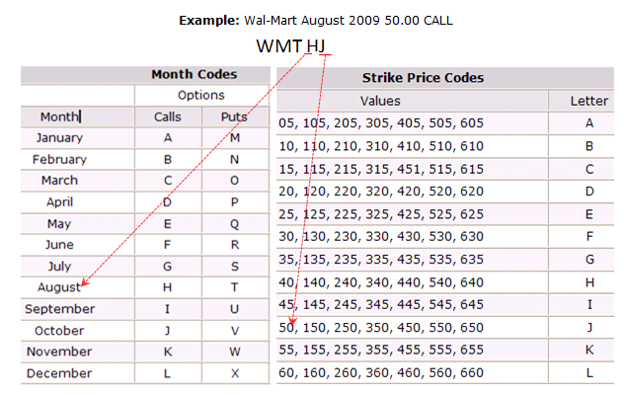
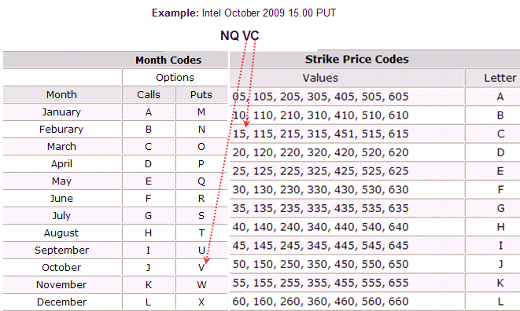

CURRENT DTN SYMBOLOGY

WMT HJ
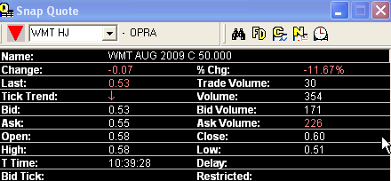

Example: Intel October 2009 PUT

NQ VC
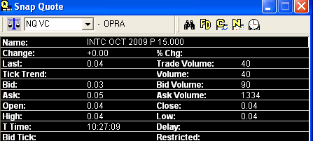

NEW OSI COMPLIANT SYMBOLOGY

WMT0922H50

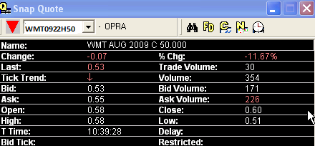

Example: Intel October 2009 PUT
INTC0917V15

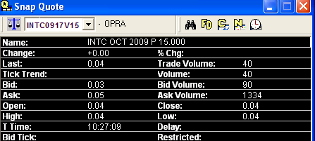

DTN TEST PLANS

-We will process and capture test data sent by OPRA.
-We will coordinate with our partners to replay the data in a testing environment.
-3rd party affiliates will be notified when the new symbology has been implemented on our preproduction system.
-We plan to provide access to our preproduction environment to our redistributor partners.
-In November we plan on running parallel within our preproduction environment (old format and new format).
-At this time, we have no plans to run parallel (old and new format) in a production environment.

OCC SCHEDULE AND CUT-OVER TO NEW DTN OPTIONS SYMBOLOGY

OCC Implementation Schedule:
• September 2009 - January 2010 - Scripted industry testing of the new environment under OSI pre and post symbol consolidation.
• February 12, 2010 - Mandatory cut-over for use of explicit data elements by all market participants .OPRA codes become obsolete and will be suppressed from all data interfaces on this date. (Symbols will not be consolidated at this time but all explicit data elements must be used).
• March 2010 – May 2010 – Execution of the symbol consolidation strategy that mitigates operational risk and ensures an efficient consolidation of all open interest.

Anticipated DTN implementation date: January 25, 2010 or February 1, 2010

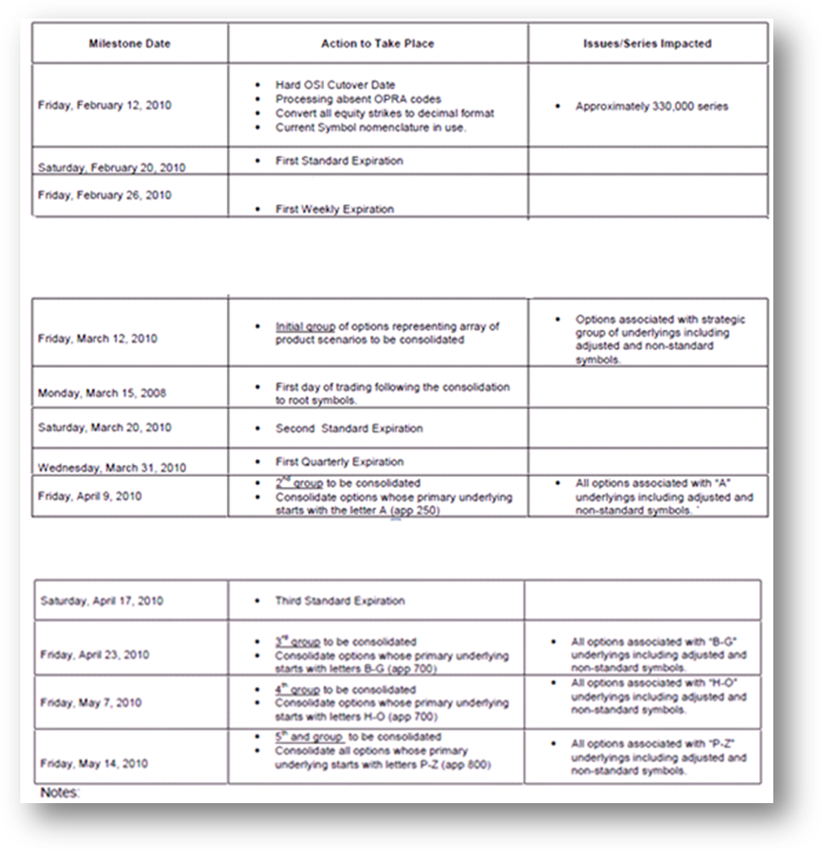

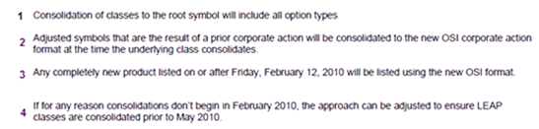

COMMUNICATIONS
Additional communications and documentation will be published as more information becomes available. For questions regarding this initiative, please contact DTN customer service.

